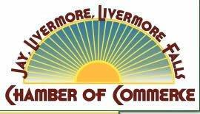
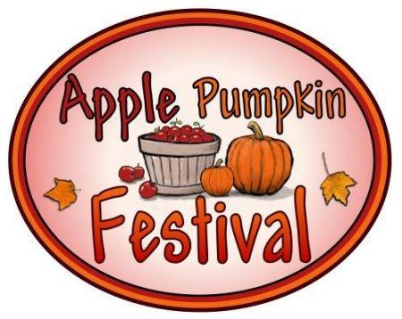

Jay – Livermore – Livermore Falls
Chamber of Commerce

2021 Apple Pumpkin Festival Vendor Instructions and Rules

The Apple Pumpkin Festival is scheduled for Saturday, September 25, 2021, from 10:00a.m. to 3:00p.m. Set up begins at 7 a.m. You will need to provide your own power, canopy(with anchors), table, and chairs. Booth size is approximately 16’ x 16’. No site reservations. NO RAIN DATE. NO REFUNDS ISSUED FOR ANY REASON.

ALL REGISTRATIONS RECEIVED FROM 9/17-9/24 WILL BE $60.
GATE ADMISSION DAY OF FESTIVAL WILL BE $80.

We accept payment via PayPal, credit card, and check. Payments accepted with credit cards, contact Chris at the Chamber 500-2464 or online at http://www.jay-livermore-lf.org or at tent the day of event (for walk ons only).
Rules for setup and safety:
- Vehicles are allowed on the field until 10am and after 3 pm. No vehicles are allowed to move on the field from 10am until 3pm. This will be strictly enforced by the Livermore Falls Police Department. If you have an emergency and need to leave, please call Bob Berry at 931-9931 to be escorted off the field.
- Park vehicles in the designated vendor parking area. Musicians may park in the designated music parking area.
- Booth location will be as designated by APF staff. Preference will be given on a first-come basis, but will be restricted to the vendor booth locations as shown on the map. If more vendors come than anticipated, vendor area will be extended southerly.
- Vendors using open flames or hot grease (not including electric hot plates or electric food warmers) must set up in the designated food vendor area.
- Generators may be used. Vendors with generators MUST pick a spot near the parking area for the generator and run an extension cord. Generators are to be placed behind a vehicle for a noise barrier.
- Need help? Have a question? Seek out someone in a bright orange APF staff shirt. We are looking for ways to help you make this an awesome event!
  - Participation is at your own risk. Attached waiver must be signed.
  - Lunch is available on the field from food vendors at your cost.
  - Your picture might be taken and you agree that we can use it for marketing purposes

Jay – Livermore
Livermore Falls
Chamber of Commerce
2021 Apple Pumpkin Festival Registration
Name:_________________________Signature:______________________Town:​________________​ State:​_______​ Zip:​___________________
Contact Name:​________________Emergancy Contact:______________
Phone:​__________________​​_____________________________ E­mail:​______________________​Website:_______________________
Briefly describe your booth or display____________________________ __________________________________________________________
[ ] I am a VENDOR USING OPEN FLAMES OR HOT GREASE (MUST SET UP IN DESIGNATED AREA.)
The Apple Pumpkin Festival is scheduled for Saturday, September 25​, 2021, from 10:00a.m. to 3:00p.m. Set up begins at 7 a.m. You will need to provide your own power, canopy (with anchors), table, and chairs. Booth size is approximately 16’ x 16’. No site reservations.​ ​NO RAIN DATE. NO REFUNDS ISSUED FOR ANY REASON.
PAID BY: | Chamber Member |  | Non- Chamber Member
 | Regular | Non-profit | Regular | Non-profit
7/1/21 - 8/31/21 | $35 | $15 | $40 | $20
9/1/21 - 9/16/21 | $45 | $25 | $50 | $30
9/17/21 - 9/24/21 | $60
9/25/21 | $80
FOOD VENDOR | $40
EXHIBITOR*  NO selling, strictly educational, as determined by APF committee | $0
Payment via PayPal, check, or credit cards with registration. Please contact Christine Fournier at the Chamber office for assistance, (207)500-2464.​ ​Please return form to: JL­LF Chamber PO Box 458, Livermore Falls, ME 04254.

